**CAT Computer Build**

|  |  |  |  |  |  |  |
| --- | --- | --- | --- | --- | --- | --- |
| **User’s Name:** | | |  | **Job Number:** |  | |
| **Network Login:** | | |  | **Password:** |  | |
| **Installed by:** | | |  | **Role:** |  | |
| **Serial Number:** | | |  | **Old Serial Number:** |  | |
|  | | | |  | | |
|  | | **Item** | | | | |
|  | Redirect Documents folder to U drive (Documents > Properties > Location) | | | | |
|  | Check Fetch opens in Chrome | | | | |
|  | Copy Desktop files from old computer (\\”old computer”\c$) | | | | |
|  | Install Printers (For new employees, find similar user in \\ad.ggh.co.nz\auditedlogons$ and copy theirs) | | | | |
|  | Check Network Drive mapping (Check audited logins \\ad.ggh.co.nz\auditedlogons$) | | | | |
|  | Copy over bookmarks from old PC – paste in same location on new PC (c:\users\”username”\appdata\local\google\chrome\userdata\default\boomarks.file) | | | | |
|  | Windows updates (and/or Dell/HP) | | | | |
|  | Disable offline files (Sync Center) | | | | |
|  | Delete reg key (Open  HKEY_LOCAL_MACHINE\SYSTEM\CurrentControlSet\Control\Power\PowerSettings\238C9FA8-0AAD-41ED-83F4-97BE242C8F20\7bc4a2f9-d8fc-4469-b07b-33eb785aaca0 | | | | |
|  | Block sleep in BIOS | | | | |
|  | Install .NET Framework 3.5 (<https://itsdterracat.zendesk.com/hc/en-nz/articles/1500011414482-Install-Net-framework-3-5>) | | | | |
|  | Install Microsoft Teams | | | | |
|  | Change setting when lid closes to “**do nothing**” (Settings > System > Power&Sleep > Additional power settings > Choose what closing the lid does) | | | | |

**Please review the installation/recommendation lists from Andrew Stockdill**

**PART I - SOFTWARE:**

|  |  |
| --- | --- |
|  | Electronic Technician (download from <https://dealer.cat.com/en/ps/service/software/cat-et.html> or Resources Drive) |
|  | SIS2GO - (App from Windows Store)  *Has replaced SIS USB* |
|  | Technician Toolbox – Replaces VIMSPC (download from Resources Drive) |
|  | PLUS+1 Service Tool (download from <https://dealer.cat.com/en/ps/service-tools.html> or Resources drive) |
|  | Danfoss+1 Service Tool (R:\Caterpillar Applications\Caterpillar Software (ET SIS STW VIMS)\AA Danfoss - Plus+1 Software) |
|  | USB to Serial Adapter Drivers (old and new part number as both adapters are still being used in the field) |
|  | Comm Adapter 3 (download from resources drive) |

**Not all Technicians need the following. Check with them or their manager to see if they do need**

|  |  |
| --- | --- |
|  | IQAN (only needed on selected laptops who have existing subscriptions).  License key obtained from Tech Services |
|  | CDVR PC Software (Used by Technicians who do generator work).  Download from SIS Web ‘Downloads’ page |
|  | Olympian Compass - Standalone (Used by Technicians who do generator work) |
|  | Challenger Technician (download from Resources Drive) |
|  | M300 Technician (download from Resources Drive) |
|  | Engine Reprogramming Tool – ERT (download from <https://dealer.cat.com/en/ps/service/software/downloads.html> |

**PART II - INSTALLATION REQUIREMENTS:**

**Electronic Technician**

|  |  |
| --- | --- |
|  | License the software before dispatching laptop or license when received by technician.  Software license (Activation ID) to be requested from Tech Services (Andrew Stockdill). When requesting New Activation ID please provide laptop serial number, Technicians Name and Branch Location. If transferring ET from existing laptop please provide details of old laptop (S/N, User Detail) and details of replacement laptop (laptop serial number, Technicians Name and Branch Location). |
|  | Make sure ET is started after installed and licensing completed (there is an occasional loss of mfc140u.dll file from the ‘C:\Windows\SysWOW64’ folder and the ‘C:\Windows\System32’ folder. |
|  | In ET Preferences disable the ‘Automatically Connect Upon Startup’ setting, select the PDF option in Product Status Report tab and ‘Check All’ in the Product Status Report tab. |
|  | Ensure Technician or the laptop is in the group for automatic ET updates |

**SIS USB (Typically only Field Service)**

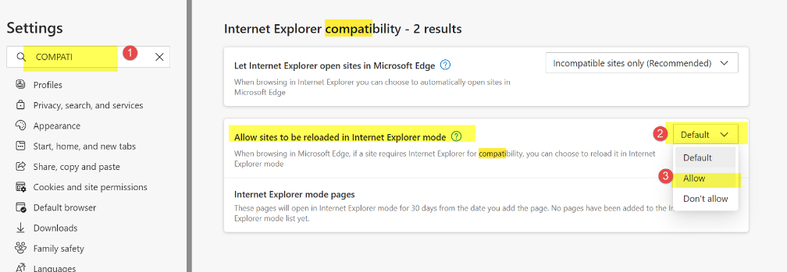

|  |  |
| --- | --- |
|  | License the software before dispatching laptop or license when received by technician.  Software license (Activation ID) to be requested from Tech Services (Andrew Stockdill). When requesting New Activation ID please provide laptop serial number, Technicians Name and Branch Location. If transferring ET from existing laptop please provide details of old laptop (S/N, User Detail) and details of replacement laptop (laptop serial number, Technicians Name and Branch Location). |
|  | Install relevant ‘Data Month’ from USB |
|  | Load Dealer SIS USB User Profile.  This is the file which sets SIS USB Username (GGHSIS) and Password (TRACK) *Both in capitals* |
|  | Under IE Tools, select Internet Options.  Select ‘Security Tab’, select ‘Trusted Sites’, click on ‘Sites’ and check ‘https://127.0.0.1’ is listed.  If not there, please add it.  Making this change prevents error message about not being able to view graphics in ‘protected mode’ when outside data coverage area. |
|  | Install plugins x4 (DJVU, IsoView, Creoview, DJVUWebBrowserPlugin) |
|  | Validate all three graphics drivers (DjVu, IsoView and CreoView) are functioning correctly, this exercise is best done using F7G prefix.  For DjVu check the parts image for the camshaft, for IsoView check the Disassembly/Assembly detail for the camshaft and for CreoView check the 241-3750 Travel Motor Lines Group. |
|  | Make Microsoft Edge IE compatible – once you have selected **ALLOW,** you will be prompted to restart the browser. |

**Don’t forget to return the IT SIS USB license if you used it to action the above**

**Technician Toolbox (Replaces VIMSPC)**

|  |  |
| --- | --- |
|  | Software needs to be installed, there is no license.  A copy of the latest software can be found in then ‘Resources’ Drive. |

**PART III - EXTRA’S / RECOMMENDATIONS**

|  |  |
| --- | --- |
|  | Consider the amount of time a laptop will remain ‘Unlocked’ for.  We use to have a ‘service group’ that allowed users in this group to keep their laptop unlocked for an hour. The purpose behind this group was to avoid a laptop ‘locking’ while flashing software into a machine/engine ECM. We’ve had a couple of instances (not recently) where screen lock activated during a software upload resulting in ECM failure. There are also other side effects that don’t always result in ECM failure, but take a lot of time to recover / resolve. |
|  | Laptops should have SIM card for Network Access (subject to branch manager / IT approval) |
|  | Set up DameWare to allow Tech Services ability to control laptop remotely.  All new laptops have been going out where we have ability to view remotely, but not control mouse or keyboard.  The ‘**View Only** for these account types’ setting needs to be disabled (unchecked).  This can be seen under the access tab of the ‘DameWare Mini Remote Control Properties’ window. |

**Check with Employee on any other extra apps they need possibly from Dealer.cat.com**